Test mobility scenarios and their consequences in Zadar FUA
Project Number | DTP1-1-037-3.1
Project Name | Comprehensive Elaboration of Strategic plans for sustainable Urban Transport
Project Acronym | CHESTNUT
Work package | WP3 - Transnational strategy
Activity | Activity 3.2 – Elaboration of Transnational Strategy (based on mobility scenarios)
Title of Working Document | Test mobility scenarios and their consequences in Zadar FUA
WP responsible partner | Pannon Business Network - PP8
Dissemination Level | Public
Date of Preparation | 17. 11. 2017.
This document must be referred to as | Test mobility scenarios and their consequences in Zadar FUA
Author | Josip Faričić, full professor  Tome Marelić, research assistant  Anica Čuka, associate professor
Contributors | Ana Pejdo, assistant professor

Document History
Version | Date | Note
Template | 02.10.2017 | Template by Takeru Shibayama (VUT)
Scenario finished | 17.11.2017. | Josip Faričić, full professor

1. Information about this test scenario
FUA Name | Zadar
Scenario Name | Business-as-usual
Date | 17. 11. 2017.
Policy target year | 2025
Contributor | Josip Faričić, full professor  Ana Pejdo, assistant professor  Tome Marelić, research assistant  Anica Čuka, associate professor

2. Describe this scenario
- Max. in 10 lines
FUA Zadar will continue current transport/mobility policy until 2025; EU, National and Regional Policies will not change until 2025. SUMP and its implementation will provide better mobility conditions for different users. Common vision for the entire FUA Zadar identifies priorities such as development of cycling network, better coordination of public transport, modernization of infrastructure and implementation of smart and innovative transport solutions.
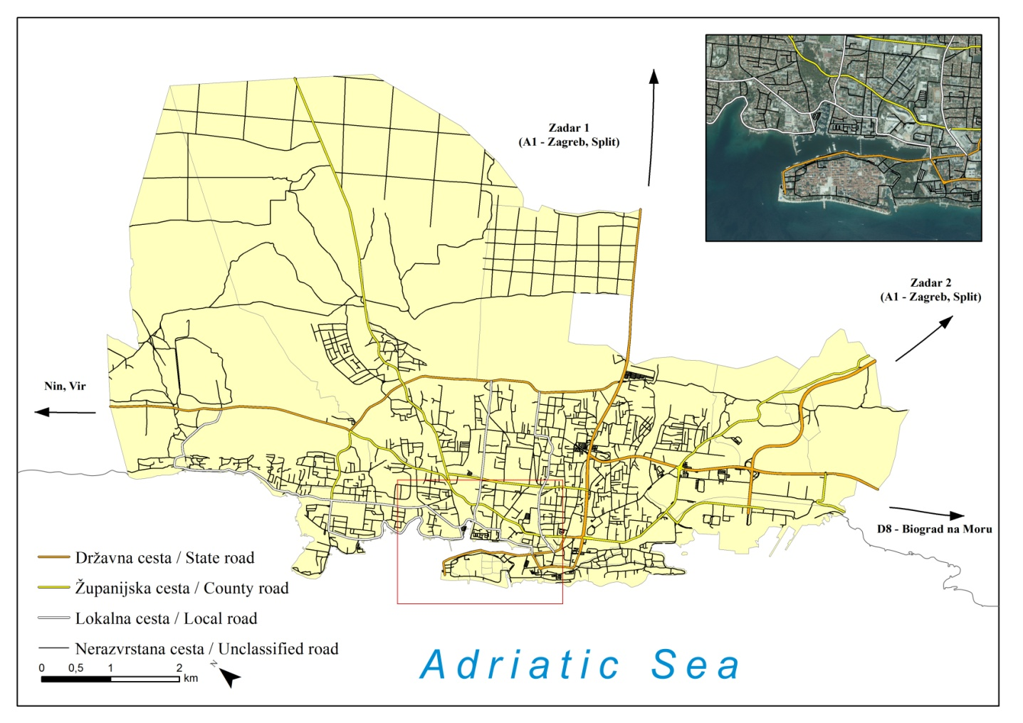
The existing transport infrastructure is the result of century long development, gradual urbanisation and the spreading of the city. Future transport system needs to be adjusted to the new redistribution of population and economic activities in the City of Zadar but also in the entire FUA. Special attention should be addressed to the significant increase of population number during summer months due to tourist arrivals. Total number of tourists in Zadar in 2016 was 421.130.

3. Assessment of consequences
How will the demographic structure of your FUA and the core city in it be in your planning horizon around 2025 to 2030? (No of population, age structure, etc.)
FUA Zadar population slightly increased during the last ten years. In relation to previous decades this increase is rather small. However, along with Zagreb and other settlements in its vicinity, Zadar is one of the rare settlements in Croatia which has recorded increase in population number according to the last official Population Census. The number of women is higher in the old age group while in the mature age group the number of woman and man is almost equal.

 | Population growth
Periods | Zadar settlement  (in %) | City of Zadar  (in %) | Other municipalities of FUA in total  (in %) | FUA total  (in %)
1970-1990 | 68,4 | 59,1 | 0,2 | 30,6
1990-2010 | -6,4 | -6,6 | -19,7 | -11,5
2010-2030 | 5,4 | 6,2 | 1,6 | 4,7

Until 2025 population number will slightly increase. Increase will be higher in City of Zadar than in other parts of FUA. In 2030 there will probably be an increase of population in the over-60s age group in the entire FUA.
 | Age structure
Age group | Zadar settlement  (in %) | City of Zadar  (in %) | Other municipalities of FUA in total  (in %) | FUA total  (in %)
0-14 | 9,0 | 9,3 | 4,5 | 13,9
15-39 | 21,2 | 21,8 | 10,6 | 32,5
40-64 | 24,8 | 25,5 | 11,3 | 36,9
65-84 | 11,7 | 12,3 | 5,6 | 17,9
85+ | 2,3 | 2,6 | 1,5 | 4,1

Which types of transport technology will have been diffused or will disappear in your FUA in your planning horizon around 2025 to 2030?
Until 2025 all transport modes will remain the same as today with more emphasis on the usage of clean vehicles and fuels. FUA Zadar in accordance with EU and National legislation will support the use of electric cars.

How will the share of transport mode change in your core city and FUA? Will there be higher share of journey with cars or less? Will it increase or decrease the share of public transport? Will there be more cyclists and walkers, or less?
Due to improvements in public transport and the cycling network there will be fewer journeys with car. The share of public transport will increase. New shipping lines will be introduced between islands. Number of pedestrians and cyclists will increase. This all will lead to air quality improvements, noise reduction and positive health effects. Dynamic of this process will depend on the implementation of proposed transport planning documentation.

Which part of your future prediction is not in line with upper-level transport policy (of region, country and EU)?
All the documentation written for FUA Zadar SUMP is in line with upper-level transport policy. In order for the document to be accepted and verified it is done using some of the main objectives and targets already stated in other Regional/National planning documentation.

Is the overall situation improving the living quality of your FUA?
Satisfaction with the technical equipment in Zadar is the highest in the statistical circles closer to city centre, i.e. that transport deficiencies are larger towards periphery meaning the location factor is extremely important for examinees satisfaction. The highest number of problems regarding transport infrastructure occur in the statistical circles Novi Bokanjac, Arbanasi 1, Arbanasi 2 and Diklo, while transport infrastructure is of high quality in statistical circles with the highest road density; Višnjik, Jazine 1, Jazine 2 and Jazine 3. Traffic jams occur during summer months when the number of transport system users doubles. In accordance with the above problems and further urban city planning it is necessary to determine perspectives of development and improvements of transport infrastructure in order to achieve a higher effectiveness, better functioning and also sustainable city development.
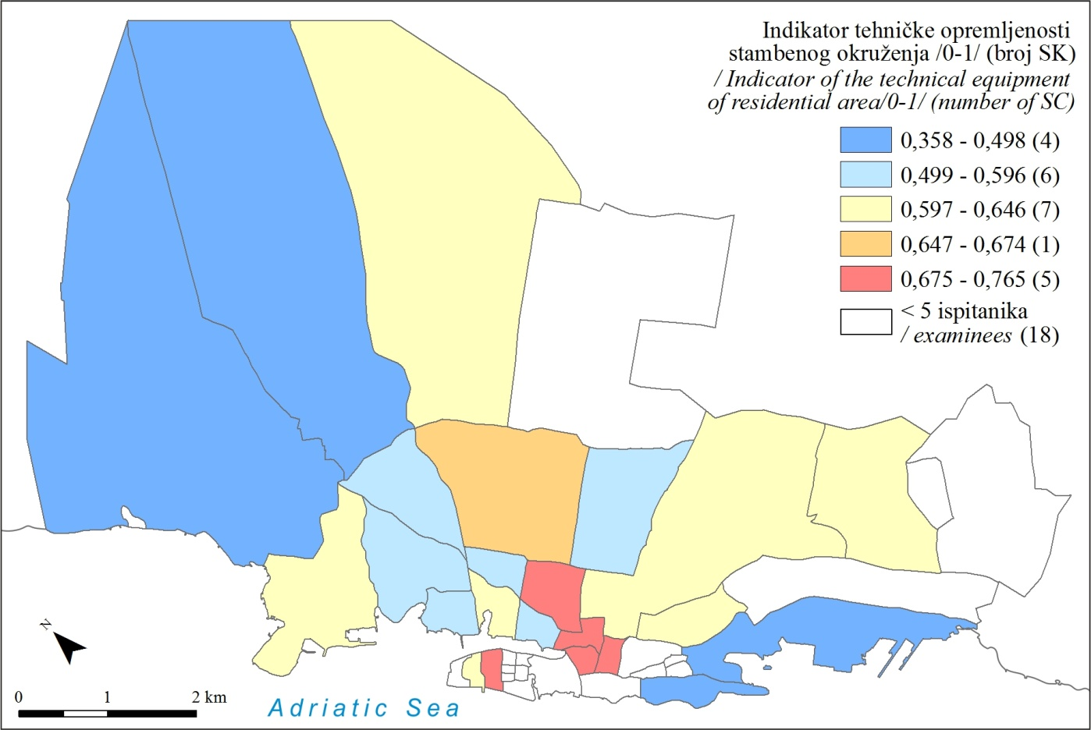

If all the priorities listed in SUMP will be implemented the quality of live will improve. In case all investments will be directed towards reconstruction of roads, building of new parking places, etc. this will cause further deterioration of living quality.

What are the effects on particular demographic groups, such as children, elderly, low-income group, foreigners and migrants, students, mobility-impaired people, etc.?
Students are also involved in daily circulations from their place of residence to primary, secondary and tertiary educational facilities located in throughout FUA. Majority of schools are located in Zadar settlement. This puts additional pressure on mobility flows. Public transport is not always in accordance with school schedule so parents often drive their children to school or back home. If SUMP priorities will be implemented it will improve citizen’s mobility and facilitate access to all urban services. Prices of public transport will decrease. At the moment there are discounts for senior citizens, school children, students and worker for buying monthly bus ticket.

How will the transport-related cost paid by each end user change? How will the transport-related cost paid by your municipalities or regional government change?
Costs are always adjusted according to the demand and the supply, local/regional public policies, taw regulations and global market trends (fuel cost). Since in Zadar FUA there are usually only one provider for every transport means prices will probably stay the same. At the moment their operations largely depend on government subsidies, especially when maritime transport is in question. The cost for the end user will probably depend on all the aforementioned parameters.

Will the overall change will lead to increase or decrease of transport-related energy consumption in your FUA?
Decreasing of the transport-related energy consumption is always one of the very important issues concerning mobility. There are no sufficient data to determine what will happen in the future. If the number of population will increase so will the transport-related energy consumption. Also introduction of new technologies and new mobility solutions may significantly increase/decrease transport-related energy consumption.

Will the overall change will lead to increase or decrease of transport-related CO2 emission in your FUA?
Overall change will lead to decrease of transport-related CO2 emission in FUA Zadar. At the moment government policy encourages reduction of CO2 emission by extra taxing cars with higher CO2 emission.

1. Information about this test scenario
FUA Name | Zadar
Scenario Name | Fostering “active” transport modes (walking and cycling) GROUP 1
Date | 17. 11. 2017.
Policy target year | 2025
Contributor | Josip Faričić, full professor  Ana Pejdo, assistant professor  Tome Marelić, research assistant  Anica Čuka, associate professor

2. Describe this scenario
- Max. in 10 lines
According to proposed documentation around 200 km of cycling lanes will be implemented in Zadar FUA until 2025. Road network in all settlements in Zadar FUA will be modified and new routes will be implemented for each mode of transport. Since the only provider for public transport in Zadar FUA is bus company only bus routes need to be adjusted. Parts of the Zadar city centre will be closed to motorized vehicles and above ground parking. Priority will be given to pedestrians. Only residential traffic, services, emergency vehicles, and loading/unloading vehicles under special circumstances will be allowed into these areas.
The most important changes will be done in the core city, especially on the Zadar peninsula which will be turned into shared space or pedestrian zone.

3. Assessment of consequences
How will the demographic structure of your FUA and the core city in it be in your planning horizon around 2025 to 2030? (No of population, age structure, etc.)
FUA Zadar population slightly increased during the last ten years. In relation to previous decades this increase is rather small. However, along with Zagreb and other settlements in its vicinity, Zadar is one of the rare settlements in Croatia which has recorded increase in population number according to the last official Population Census. The number of woman is higher in the old age group while in the mature age group the number of woman and man is almost equal.
 | Population growth
Periods | Zadar settlement  (in %) | City of Zadar  (in %) | Other municipalities of FUA in total  (in %) | FUA total  (in %)
1970-1990 | 68,4 | 59,1 | 0,2 | 30,6
1990-2010 | -6,4 | -6,6 | -19,7 | -11,5
2010-2030 | 5,4 | 6,2 | 1,6 | 4,7

Until 2025 population number will slightly increase. Increase will be higher in City of Zadar than in other parts of FUA. There will be an increase of population in the over-60s age group in the entire FUA. Turning of certain parts of the city into pedestrian zones will improve health condition for elderly population who will move more. On the other hand, public transport needs to be more efficient, so elderly population can have access to all public services even if they cannot drive by themselves any more.
 | Age structure
Age group | Zadar settlement  (in %) | City of Zadar  (in %) | Other municipalities of FUA in total  (in %) | FUA total  (in %)
0-14 | 9,0 | 9,3 | 4,5 | 13,9
15-39 | 21,2 | 21,8 | 10,6 | 32,5
40-64 | 24,8 | 25,5 | 11,3 | 36,9
65-84 | 11,7 | 12,3 | 5,6 | 17,9
85+ | 2,3 | 2,6 | 1,5 | 4,1

Which types of transport technology will have been diffused or will disappear in your FUA in your planning horizon around 2025 to 2030?
Until 2025 all transport modes probably will remain the same as today with more emphasis on the usage of clean vehicles and fuels. FUA Zadar in accordance with EU and National strategic documents will support the use of e-bikes.

How will the share of transport mode change in your core city and FUA? Will there be higher share of journey with cars or less? Will it increase or decrease the share of public transport? Will there be more cyclists and walkers, or less?
Due to improvements in public transport and the cycling network there will be fewer journeys with car. The share of public transport will increase. New shipping lines will be introduced between islands. Number of pedestrians and cyclists will increase.

Which part of your future prediction is not in line with upper-level transport policy (of region, country and EU)?
Fostering “active” transport modes (walking and cycling) is in line with all upper-level transport policies; regional/national/EU. In all the mentioned official documents needs of an individual are in the centre of their focus with special emphasis on increasing the share of walking and cycling. There is a plan for turning historic Zadar city centre into shared pedestrian zone since majority of tourist attractions but also public and governmental services/offices are located there.

Is the overall situation improving the living quality of your FUA?
If all the priorities listed in the description of this scenario will be implemented the quality of life will improve. This all will lead to air quality improvements, noise reduction and positive health effects.

What are the effects on particular demographic groups, such as children, elderly, low-income group, foreigners and migrants, students, mobility-impaired people, etc.?
School children and adults using bicycles can reduce their commute times. Majority of them would use bicycles more if there were cycling lanes they could use. For children it is very dangerous to cycle if they are using the same paths as cars. Cycling could be much faster than driving in cars, so they would have more time to study, to relax, to associate, etc. If e-bikes were introduced even elderly people could cycle more, especially during rush hours.

How will the transport-related cost paid by each end user change? How will the transport-related cost paid by your municipalities or regional government change?
Costs are always adjusted according to the demand and the supply, local/regional public policies, taw regulations and global market trends (fuel cost). Regardless positive effects cycling and walking or implementation of superblocks and pedestrian areas could have on their health residents will object if the taxes and the costs of everyday life increase due to investments in transport infrastructure. Municipality will need to invest more in infrastructure; building of new cycling lanes, buying e-bikes, etc. Costs will depend on the all aforementioned factors.

Will the overall change lead to increase or decrease of transport-related energy consumption in your FUA?
The transport-related energy consumption will decrease if more people will walk or cycle.

Will the overall change lead to increase or decrease of transport-related CO2 emission in your FUA?
Overall change will lead to decrease of transport-related CO2 emission in FUA Zadar.

1. Information about this test scenario
FUA Name | Zadar
Scenario Name | EU Policy to prohibit private car ownership by 2045 (GROUP 2)
Date | 17. 11. 2017.
Policy target year | 2025
Contributor | Josip Faričić, full professor  Ana Pejdo, assistant professor  Tome Marelić, research assistant  Anica Čuka, assistant professor

2. Describe this scenario
- Max. in 10 lines
EU decides to prohibit private car ownership until 2025, with 20-year transition period. According to proposed documentation any type of cars will be allowed to be owned by companies, but not allowed by private person. Car-sharing scheme will be introduced in all parts of Zadar FUA. Number of cars on the roads will decrease significantly. Population will cycle, walk and use public transport more. Children will go to school only by school buses., cycle or on foot.

3. Assessment of consequences
How will the demographic structure of your FUA and the core city in it be in your planning horizon around 2025 to 2030? (No of population, age structure, etc.)
FUA Zadar population slightly increased during the last ten years. In relation to previous decades this increase is rather small. However, along with Zagreb and other settlements in its vicinity, Zadar is one of the rare settlements in Croatia which has recorded increase in population number according to the last official Population Census. The number of woman is higher in the old age group while in the mature age group the number of woman and man is almost equal.
 | Population growth
Periods | Zadar settlement  (in %) | City of Zadar  (in %) | Other municipalities of FUA in total  (in %) | FUA total  (in %)
1970-1990 | 68,4 | 59,1 | 0,2 | 30,6
1990-2010 | -6,4 | -6,6 | -19,7 | -11,5
2010-2030 | 5,4 | 6,2 | 1,6 | 4,7

Until 2025 population number will slightly increase. Increase will be higher in City of Zadar than in other parts of FUA. There will be an increase of population in the over-60s age group in the entire FUA. Turning of certain parts of the city into pedestrian zones will improve health condition for elderly population who will move more. On the other hand public transport needs to be more efficient so elderly population can have access to all public services even if they cannot drive by themselves any more.
 | Age structure
Age group | Zadar settlement  (in %) | City of Zadar  (in %) | Other municipalities of FUA in total  (in %) | FUA total  (in %)
0-14 | 9,0 | 9,3 | 4,5 | 13,9
15-39 | 21,2 | 21,8 | 10,6 | 32,5
40-64 | 24,8 | 25,5 | 11,3 | 36,9
65-84 | 11,7 | 12,3 | 5,6 | 17,9
85+ | 2,3 | 2,6 | 1,5 | 4,1

Which types of transport technology will have been diffused or will disappear in your FUA in your planning horizon around 2025 to 2030?
Until 2025 all transport modes will probably remain the same as today with more emphasis on the usage of clean vehicles and fuels. FUA Zadar in accordance with EU and National legislation will support the use of electric cars.

How will the share of transport mode change in your core city and FUA? Will there be higher share of journey with cars or less? Will it increase or decrease the share of public transport? Will there be more cyclists and walkers, or less?
There will be fewer trips with cars while the share of cycling, walking and usage of public transport will increase. Since car-sharing is still not introduced in Zadar FUA implementation of such model would be very difficult. People think of their car as very valuable personal property and are used to moving from one place to another by car. Car gives them sense of freedom; they are independent and plan their activities according to their wishes. This allows them maximum freedom and even if they are aware of traffic jams in the summer or during rush hours they usually choose car instead of cycling, walking or public transport.

Which part of your future prediction is not in line with upper-level transport policy (of region, country and EU)?
This type of scenario is not in line with all upper-level transport policies; regional/national/EU. In all the mentioned official documents it is emphasized that cars should be used less but Zadar FUA citizens can own a car. If they want they can use car-sharing but it is their legal right to own a car if they choose so.

Is the overall situation improving the living quality of your FUA?
If all the priorities listed in the description of this scenario will be implemented the quality of live will improve. This all will lead to air quality improvements, noise reduction and positive health effects. Fewer cars on the street mean fewer traffic accidents and safer streets for all.

What are the effects on particular demographic groups, such as children, elderly, low-income group, foreigners and migrants, students, mobility-impaired people, etc.?
This kind of scenario could be beneficiary for all. If there are fewer cars all other transport modes should be organised better. Only employed people could use cars for themselves and their families but other such as school children, students, elderly people, mobility-impaired people who cannot drive themselves would need to use public transport, to walk or cycle. This is one of the main reasons why this type of scenario could not be implemented in Zadar FUA in the near future. Zadar FUA has only one public transport operator, cycling network does not fulfil the needs of the local population, street spaces are not adjusted to mobility-impaired persons, etc. At the moment car is the only transport mean enabling population’s access to all facilities at all times.

How will the transport-related cost paid by each end user change? How will the transport-related cost paid by your municipalities or regional government change?
The cost for the end user will be lower. People will no longer pay all the expanses as if they own a car.

Will the overall change lead to increase or decrease of transport-related energy consumption in your FUA?
The transport-related energy consumption will decrease if more people will use cars less.

Will the overall change lead to increase or decrease of transport-related CO2 emission in your FUA?
Overall change will lead to decrease of transport-related CO2 emission in FUA Zadar.

